**Green one is the primary key,**

**red one is the foreign key,**

**Blue one is table name.**

**….…………………………………………………………………**

**Has**(Student-ID,Student-Name,CGPA,Credit-Completed,Dept-ID,

Dept-name)

**1NF-** no multivalued attribute

**2NF-**Student-ID,Student-Name,CGPA,Credit-Completed

Dept-ID,Dept-name

**3NF-**no transitive dependency

Student-ID,Student-Name,CGPA,Credit-Completed Dept-ID,Dept-name

**Table for Has-**

**1.**Student-ID,Student-Name,CGPA,Credit-Completed ,Dept-ID

**2.**Dept-ID,Dept-name

….……………………………………………………………….

**Conduct**(Dept-ID,Dept-name,Reg-No,Student-name,course-name,Marks)

**1NF-**Marks is a multivalued attribute

**2NF**-Dept-ID,Dept-name

Reg-No,Student-name,course-name,Marks

**3NF-**Dept-ID,Dept-name

Reg-No,Student-name

M-ID,course-name,Marks

**Table for Conduct-**

**3.**Dept-ID,Dept-name

**4.**Reg-No,Student-name,course-name,Dept-ID

**5.**Reg-No,Marks-composite pk

….………………………………………………………………..

**Works(**Dept-ID,Dept-name,Faculty-ID,Faculty-Name,Designation,

Hiredate**)**

**1NF-**no multivalued attribute

**2NF-**Dept-ID,Dept-name

Faculty-ID,Faculty-Name,Designation,

Hiredate

**3NF-**no transitive dependency

Dept-ID,Dept-name

Faculty-ID,Faculty-Name,Designation,

Hiredate

**Table for Works-**

**6.**Dept-ID,Dept-name

**7.**Faculty-ID,Faculty-Name,Designation,Hiredate,

Dept-ID

….………………………………………………………………………………….

**Assigned(**Faculty-ID,Faculty-Name,Designation,

Hiredate,Section-no,Section-Name**)**

**1NF-**no multivalued attribute

**2NF-**Faculty-ID,Faculty-Name,Designation,Hiredate

Section-no,Section-Name

**3NF-** no transitive dependency

Faculty-ID,Faculty-Name,Designation,Hiredate

Section-no,Section-Name

**Table for Assigned-**

**8.**Faculty-ID,Faculty-Name,Designation,Hiredate,Section-no

**9.**Section-no,Section-Name

….………………………………………………………………………………………

**Belongs to(**Section-no,Section-Name,Course-ID,Course-Name,

Course-Credit**)**

**1NF-**no multivalued attribute

**2NF-** Section-no,Section-Name

Course-ID,Course-Name,Course-Credit

**3NF-** no transitive dependency

Section-no,Section-Name

Course-ID,Course-Name,Course-Credit

**Table for Belongs to-**

**10.**Section-no,Section-Name,Course-ID

**11.**Course-ID,Course-Name,Course-Credit

….……………………………………………………………………….

**Offer(**Dept-ID,Dept-name,Course-ID,Course-Name,Course-Credit**)**

**1NF-**no multivalued attribute

**2NF-** Dept-ID,Dept-name

Course-ID,Course-Name,Course-Credit

**3NF-** no transitive dependency

Dept-ID,Dept-name

Course-ID,Course-Name,Course-Credit

**Table for Offer-**

**12.**Dept-ID,Dept-name

**13.**Course-ID,Course-Name,Course-Credit

**14.**DC-ID,Dept-ID,Course-ID

….………………………………………………………………………………..

**Select(**Student-ID,Student-Name,CGPA,Credit-Completed,Course-ID,Course-Name,Course-Credit**)**

**1NF-**no multivalued attribute

**2NF-**Student-ID,Student-Name,CGPA,Credit-Completed

Course-ID,Course-Name,Course-Credit

**3NF-** no transitive dependency

Student-ID,Student-Name,CGPA,Credit-Completed

Course-ID,Course-Name,Course-Credit

**Table for Select-**

**15.**Student-ID,Student-Name,CGPA,Credit-Completed

**16.**Course-ID,Course-Name,Course-Credit

**17.**SC-ID,Student-ID,Course-ID

**-------------------------------------------------**

**Table List-**

**1.**Student-ID,Student-Name,CGPA,Credit-Completed ,Dept-ID

->(Student10)

**2.**Dept-ID,Dept-name->(Department1)

**3.**Reg_No,Student-name,course-name,Dept-ID->(Exam)

**4.**Reg_No,Marks->(Rmarks)

**5.**Faculty-ID,Faculty-Name,Designation,Hiredate,Dept-ID,Section-no->(Faculty)

**6.**Section_no,Section-Name,Course-ID->(Section)

**7.**Course-ID,Course-Name,Course-Credit->(Course1)

**8.**DC-ID,Dept-ID,Course-ID->(Newt1)

**9.**SC-ID,Student-ID,Course-ID->(Newt2)

**1.**Student-ID,Student-Name,CGPA,Credit-Completed ,Dept-ID

->(Student10)

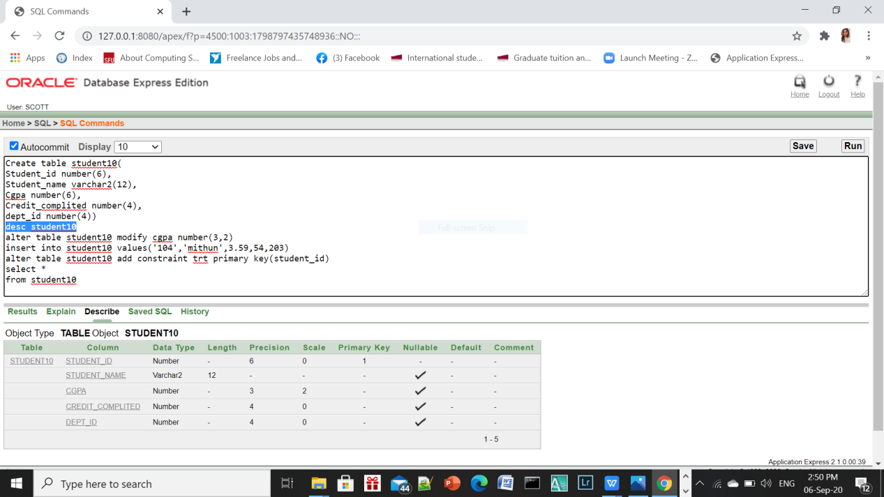

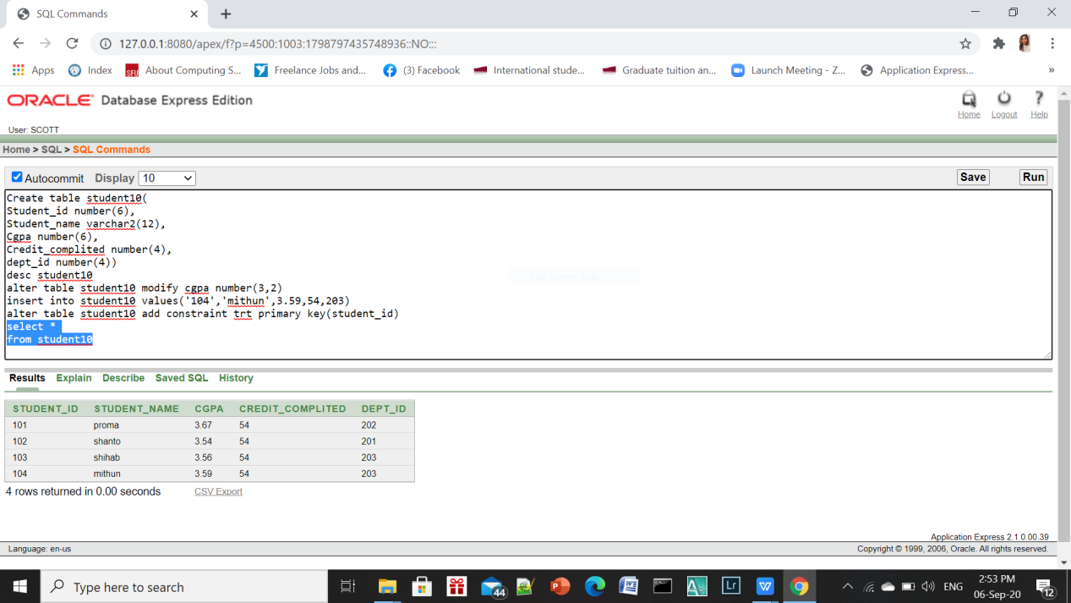

**2.**Dept-ID,Dept-name->(Department1)

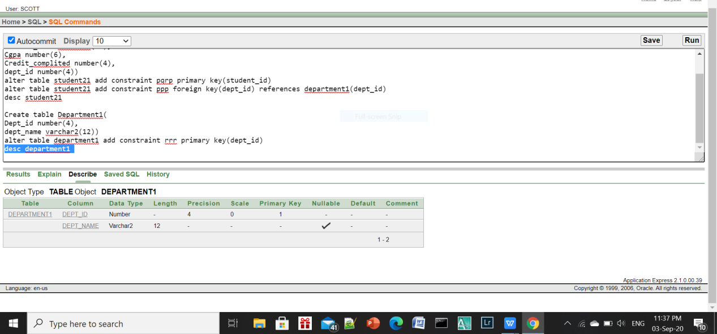

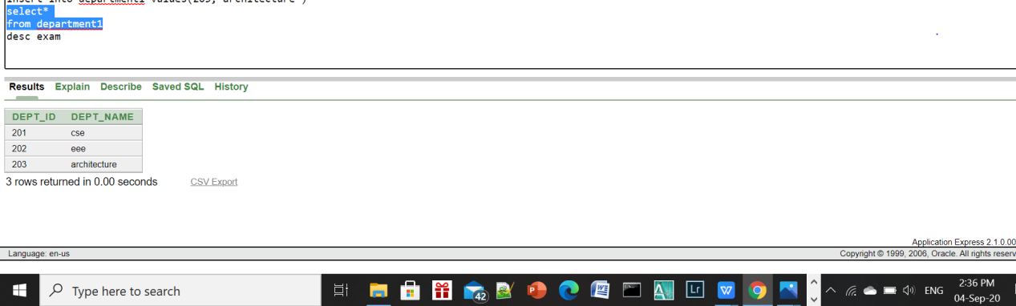

**3.**Reg_No,Student-name,course-name,Dept-ID->(Exam)

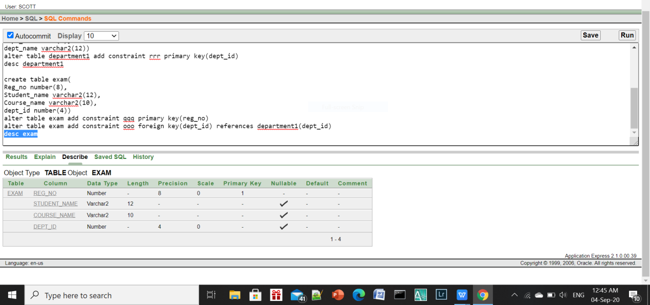

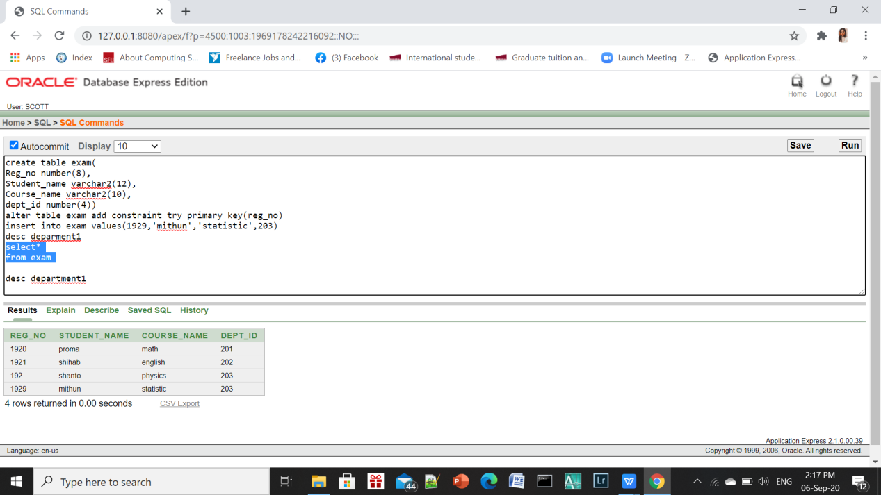

**4.**Reg_No,Marks->(Rmarks)

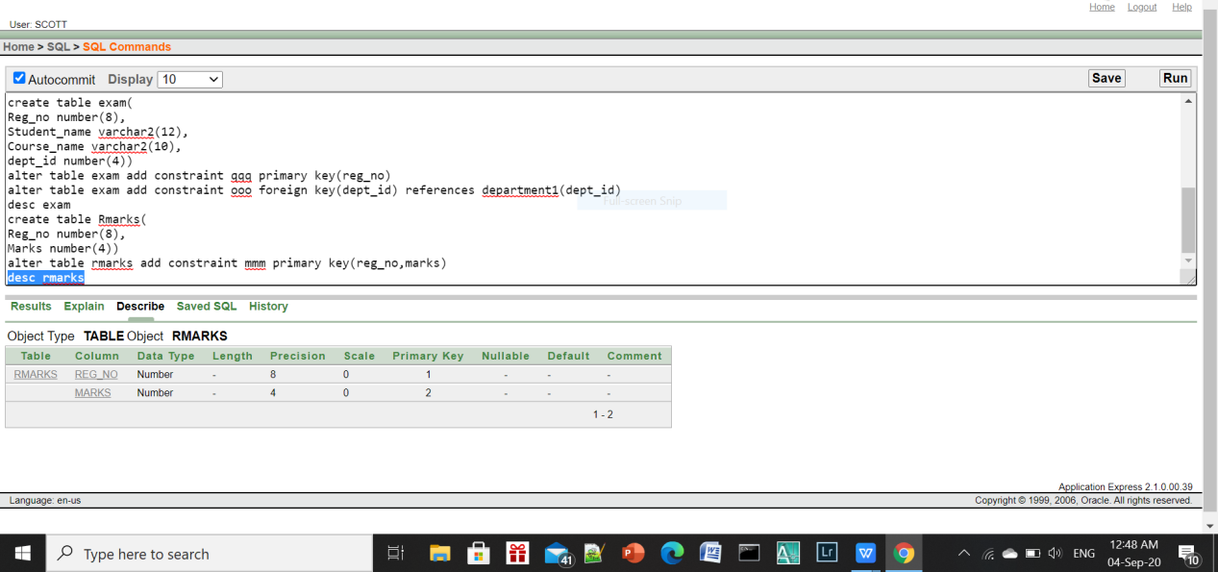

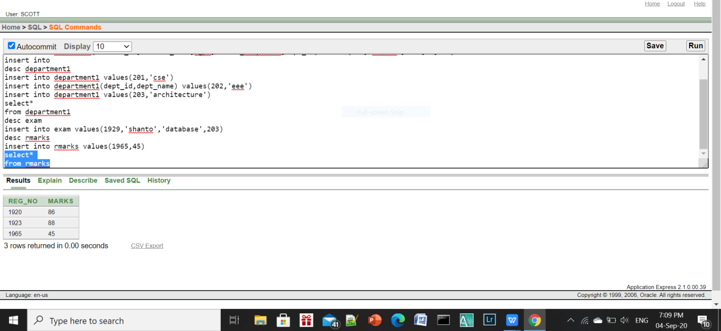

**5.**Faculty-ID,Faculty-Name,Designation,Hiredate,Dept-ID,Section-no->(Faculty)

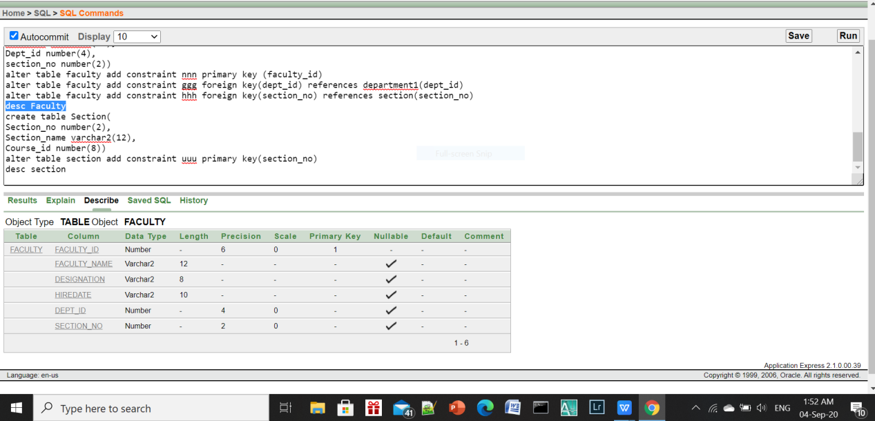

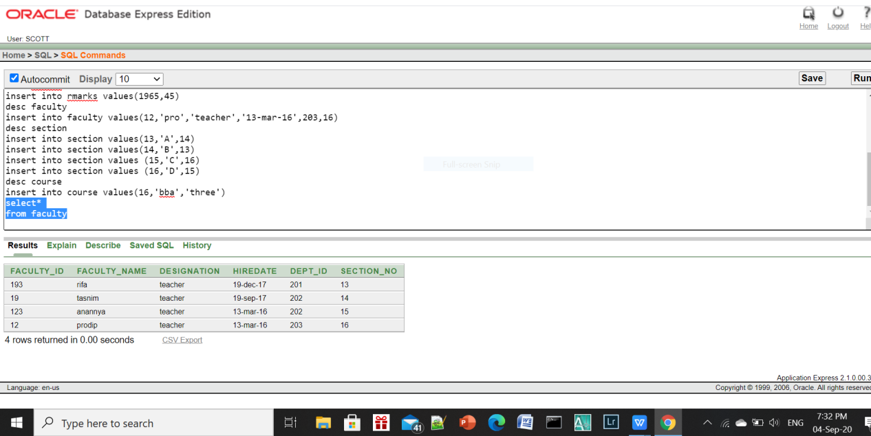

**6.**Section_no,Section-Name,Course-ID->(Section)

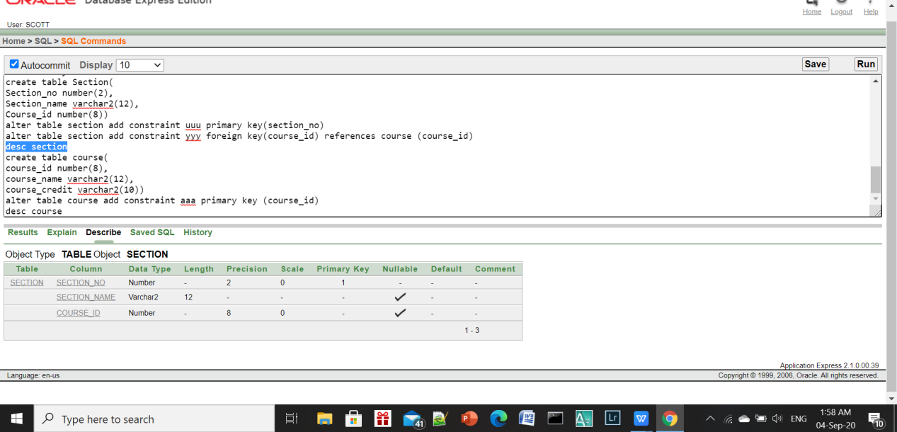

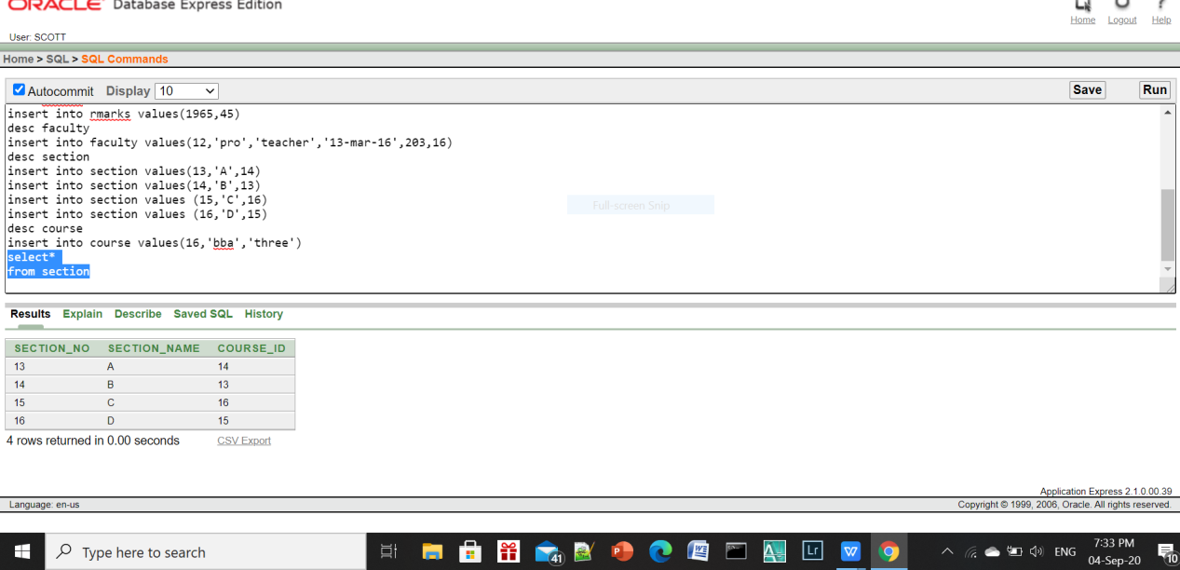

1. Course-ID,Course-Name,Course-Credit->(Course1)

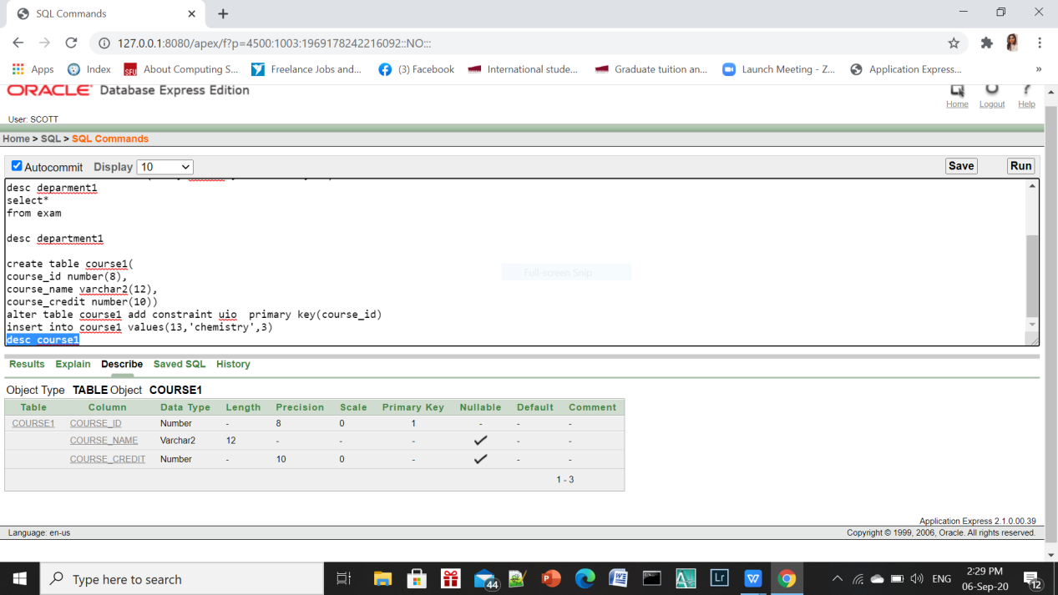

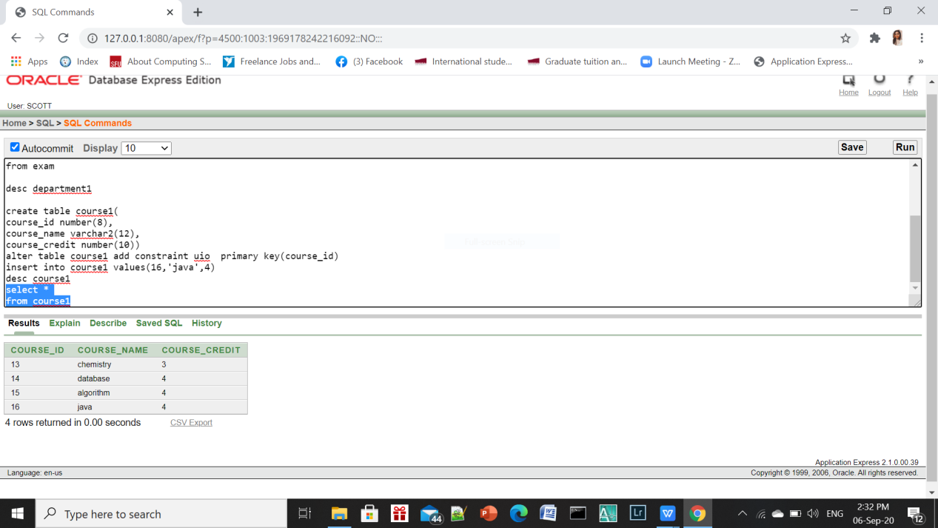

**8.**DC-ID,Dept-ID,Course-ID->(Newt1)

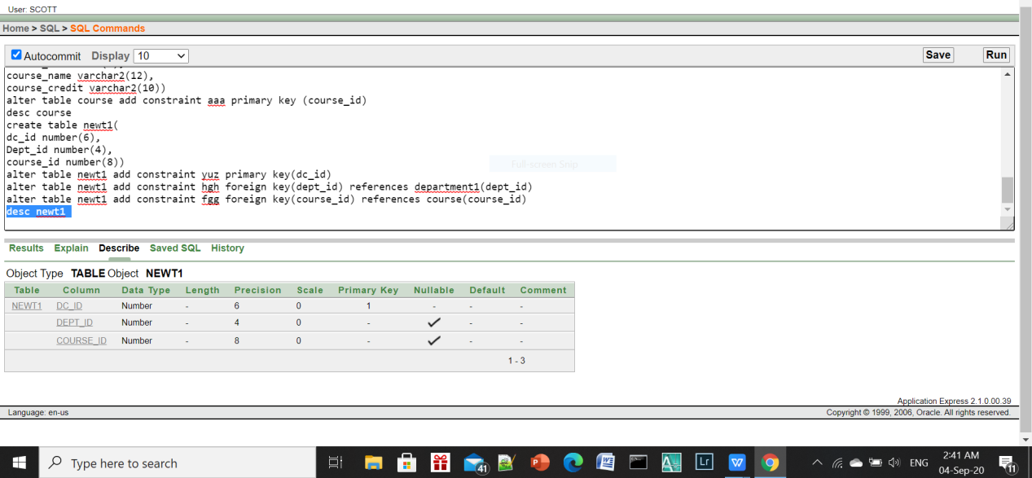

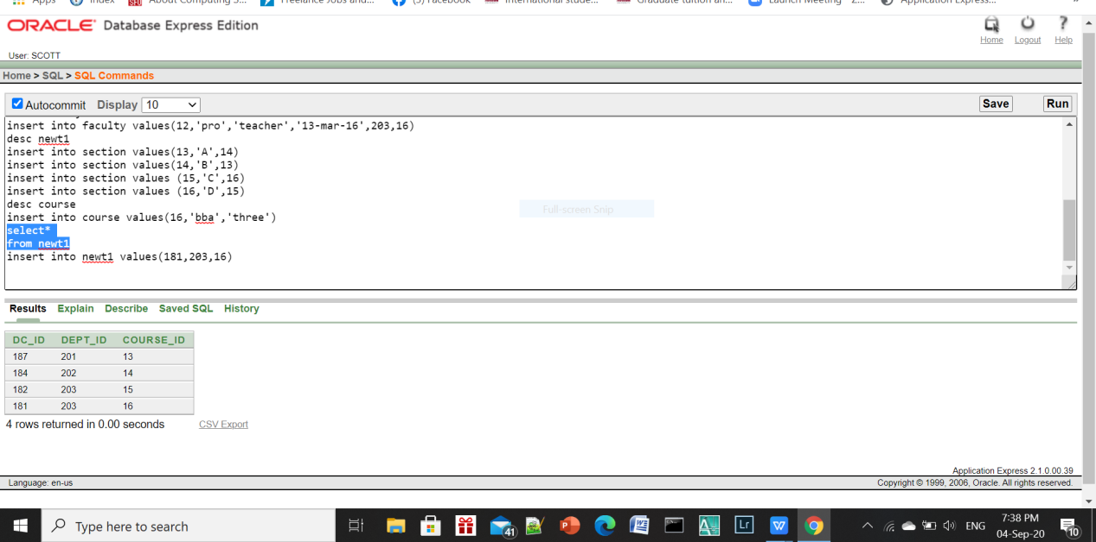

**9.**SC-ID,Student-ID,Course-ID->(Newt2)

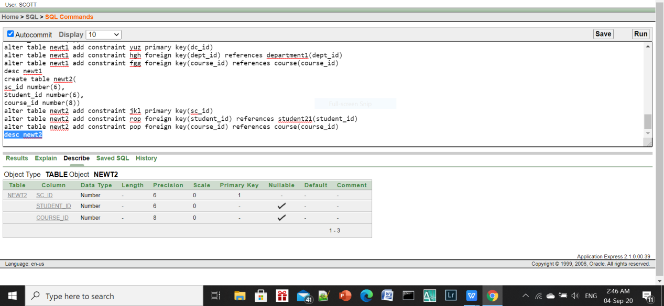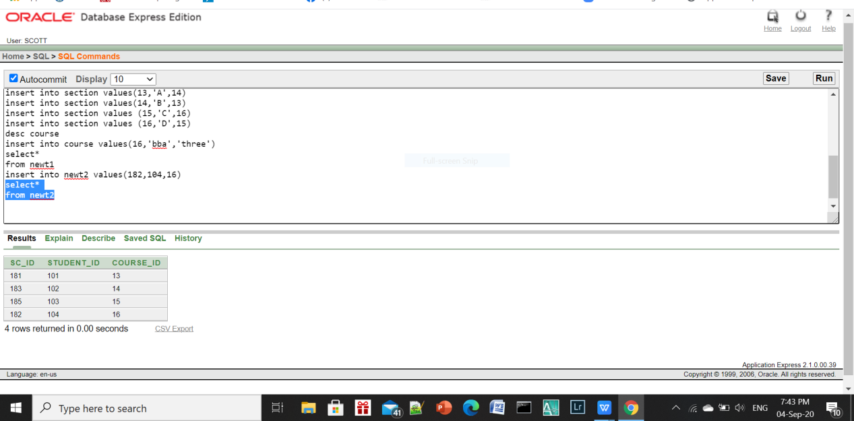

DEFAULT CONSTRAINT

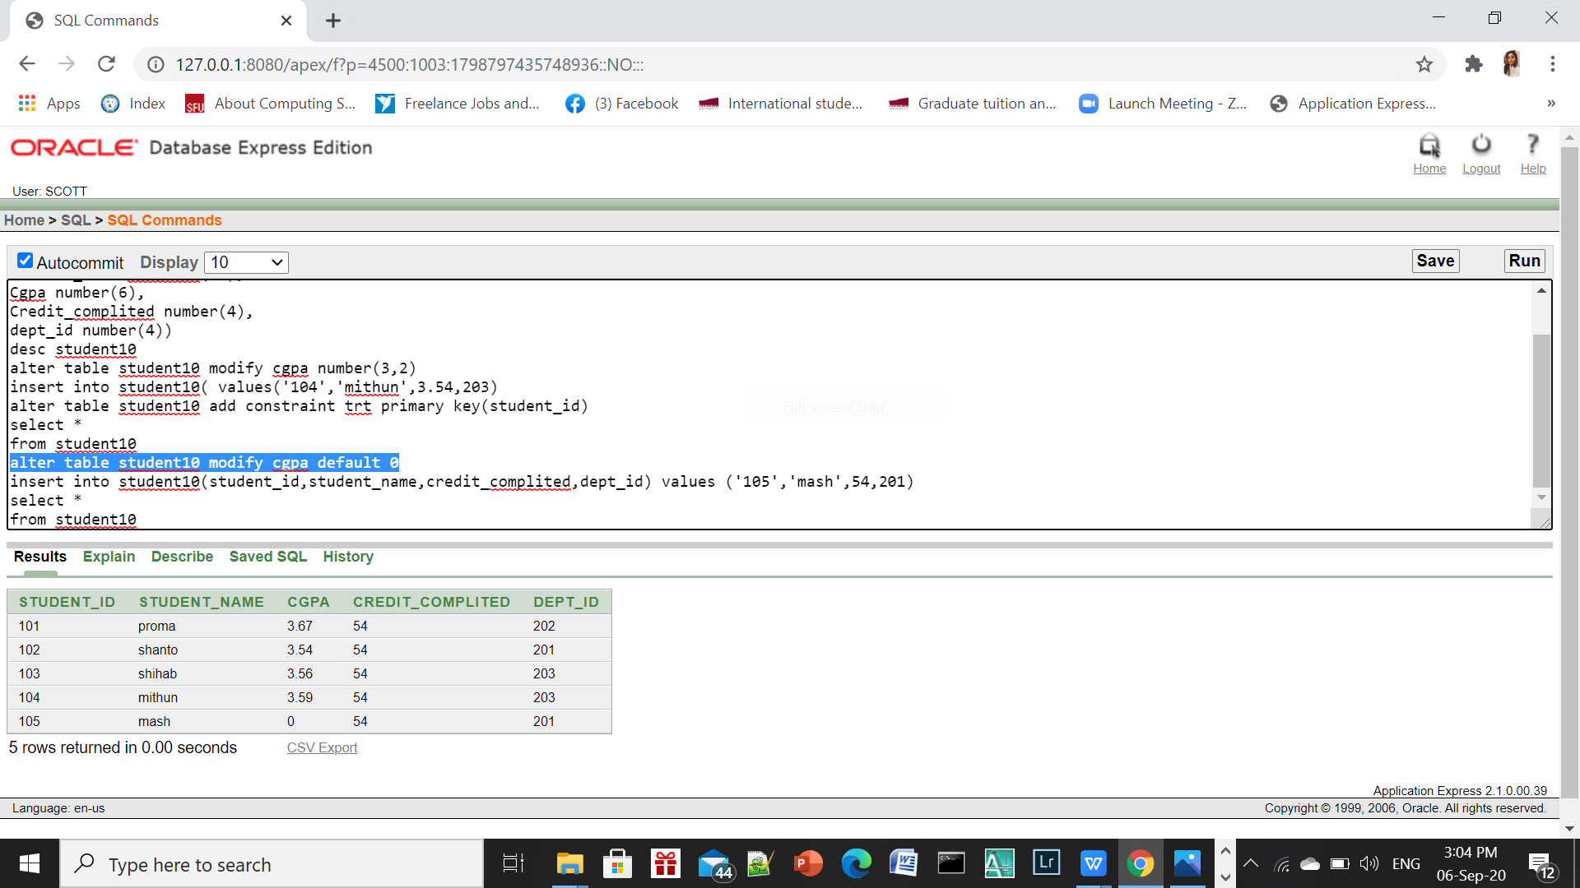

SEQUENCE

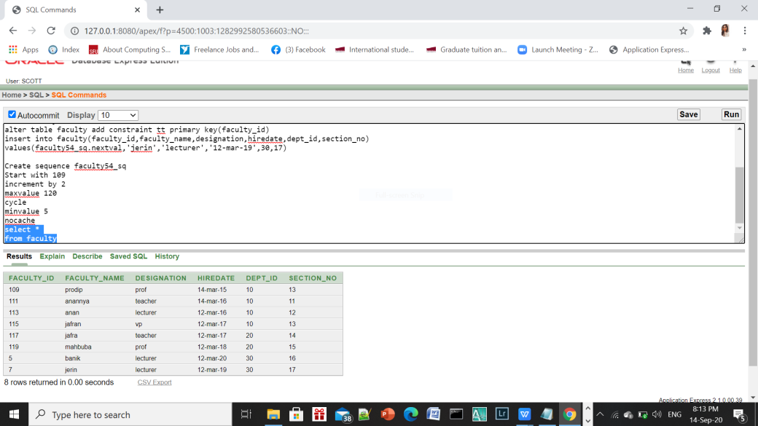

QUESTION

1.Display the Faculty name,ID,Hiredate details who joined after Prodip.And

Sort the Hiredate from highest to lowest.

2.Write a query to display the faculty name, department id and section no

whose department id is less than Anannya .

3.Display the dept name,student id who have an S in their name

and who is not cse dept (use join)

4.Display Student Name and all marks using outer join

5.Display student name and id whose CGPA is greater or Equal then 3.55

6.create a sequence named faculty_sq that can generates following sequence of value 109,111,113,115.......120(maximum value).

And create cycle having minvalue 5

7.create a sequence named faculty_sq that can generates following sequence of value 109,111,113,115.......120(maximum value).

No need to create cache or cycle

8. create a view test_exam based on the Reg_no,student_name,course_name,dept_id from the exam table.

9.create a view Dept202 that contains student_id,student_name,CGPA,credit_completed and dept_id should be 202.

do not allow student to be reassigned to another department through the view

10.write a query to display Reg_no,student_name,course_name .whose dept_id is 202.